American Society of Regional Anesthesia and Pain Medicine
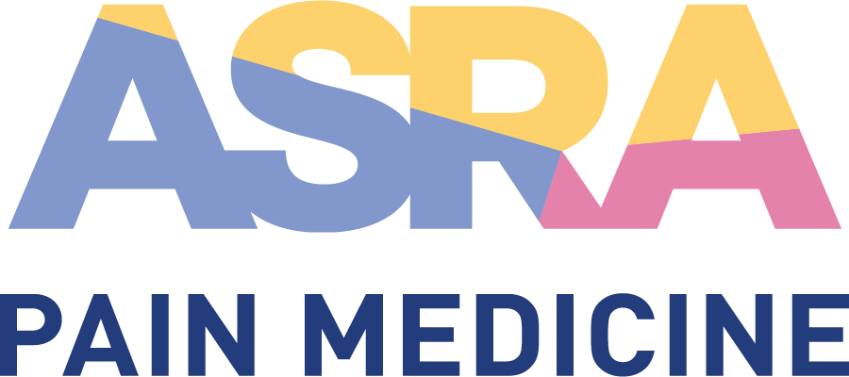

CME Policy

Activity Evaluation Framework

Title | Activity Evaluation Framework
Original Approval | 09/2012
Revisions | 07/2022, 02/2018, 08/2017, 06/2014

Purpose
ASRA Pain Medicine measures outcomes on levels 1-6 of the 2009 Moore, et al. scale using various data sources as indicated in the framework below. Information gained throughout this process is compiled and analyzed by the ASRA Pain Medicine scientific/education planning committee chair, chair +1, chair +2, president, CME committee, and ASRA Pain Medicine executive office. The educational activity is examined based on this data collection and analysis to measure its effectiveness in achieving the desired results as identified by the gap analysis, needs assessment and outlined in the educational objectives. This evaluation and outcomes analysis is a key component when planning future CME activities and evaluating the overall CME program’s level of success in meeting its CME mission.

Procedure
ASRA Pain Medicine measures outcomes on levels 1-6 of the 2009 Moore, et al. scale using various data sources as indicated in the framework below. Information gained throughout this process is compiled and analyzed by the ASRA Pain Medicine scientific/education planning committee, CME committee, and CME project management team.

- 2009 Moore, et al. Evaluation Framework

Participation (Level 1)
Description:
The number of attendees who registered and actually attended; including demographic information (degree, specialty, practice type, geographic provenance, etc.)
Data sources:
Software/database for attendance tracking and learner registration. Approximate attendance in each of the educational meeting rooms is also captured per session (headcount onsite).

Acceptance and Satisfaction (Level 2)
Description:
The degree to which participant expectations about the setting, content and delivery of the CME activity were met
Data source:
(Evaluation questions) This event met my expectations. I will attend this event again. I would recommend this event to colleagues. What did you like most about this event? What can we do to improve this event? Is there anything else you wish to tell us?

Learning: Declarative Knowledge (Level 3A)
Description:
The degree to which participants know and can state what the CME activity intended them to know, the acquisition and interpretation of facts, knowledge gain
Data source:
(Evaluation questions) Please indicate the degree to which the educational objectives were met.

Learning: Procedural Knowledge (Level 3B)
Description:
The degree to which participants know how and can state how to do what the CME activity intended them to know how to do
Data source:
(Evaluation questions) Please indicate the degree to which the educational objectives were met.

Learning: Competence (Level 4)
Description:
The degree to which participants can show how to do or state intentions to do what the CME activity intended them to be able to do
Data source:
(Evaluation questions) Participating in this educational event will improve my professional practice. I will make changes to my professional practice based on what I learned. Please describe 1-2 intended changes.

Performance/Behavior (Level 5)
Description:
The degree to which participants actually do what the CME activity intended them to be able to do once back in their practices
Data source:
(Evaluation questions) Have you made any actual changes or can you provide one example of when something you learned actually helped improve the care you provided and/or a patient’s health?

Patient Health (Level 6)
Description:
The degree to which the health status of patients improves due to changes in the practice behavior of participants
Data source:
(Evaluation questions) Have you made any actual changes or can you provide one example of when something you learned actually helped improve the care you provided and/or a patient’s health?

Community Health (Level 7)
Description:
The degree to which the health status of a community of patients improves due to changes in the practice behavior of participants
Data source:
ASRA Pain Medicine, in partnership with federal agencies, will track trends related to patients with pain to assess if ASRA Pain Medicine (in part) is improving community health outcomes.

- ASRA Pain Medicine Activity Evaluation Process

Event Evaluation (levels 1-4)
A comprehensive event evaluation is administered online at the end of the course to all attendees. The evaluation is coupled with the credit claiming process in order to obtain the CME certificate. Questions are designed to measure outcomes on levels 1-6, as outlined above, but additional questions address other key areas of effective and appropriate CME and event planning.

Evaluation Results Analysis and Recommendations
The online evaluation will close 2 weeks post-event. Within 4 weeks post-event, the Director of CME and Meetings will compile the online evaluation results with other key event data (attendance records, organizational meeting report, chair report, etc.). All data will be available in a timely fashion for subsequent CME committee and scientific/education planning committee meetings. This evaluation and outcomes analysis is a key component when planning future CME activities and evaluating the overall level of success in meeting the CME mission.

