American Society of Regional Anesthesia and Pain Medicine
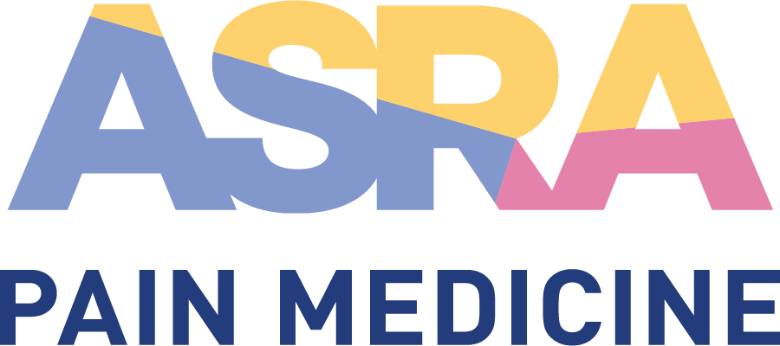

CME Policy

Associate Faculty

Title | Associate Faculty
Original Approval | 01/2014
Revisions | 02/2018, 11/2016, 02/2015, 09/2014, 03/2014

Purpose
The Associate Faculty role is an opportunity provided by ASRA to professionals who have shown an interest in becoming more involved in the Society while developing their teaching skills in the fields of regional anesthesiology, acute pain, and chronic pain medicine. They must be practicing specialists with at least some experience in providing instruction and a willingness to develop. ASRA strongly encourages the use of Associate Faculty during its educational activities as a means for encouraging development as instructors while actively supporting the ASRA educational mission.

Procedure
- Role
Associate Faculty participate only in supporting roles within standard workshop sessions (excluding comprehensive workshops). They may also participate in any portion of the resident/fellow program. Associate Faculty do not give formal presentations during plenary/parallel sessions, moderate sessions, lead PBLDs, or participate in comprehensive workshops; such sessions are reserved for full faculty members. Associate Faculty are included in all faculty activities such as receptions, dinners, etc. During the weekend cadaver courses, Associate Faculty support the hands-on portions of the program.

- Selection Process
Associate Faculty are selected by the Committee on CME and the Scientific/Education Planning Committee Chair for each event. The Chair may choose from the list of current Associate Faculty or introduce new members at his/her discretion (subject to CME Committee approval). Occasionally, ASRA will also make a call for self-nominations for Associate Faculty as follows:
- Call for applications sent to the membership and posted online.
- Application requirements include submission of a CV, letter of recommendation from an ASRA member, a personal letter of motivation (including specific expertise and teaching strengths), and confirmation of ASRA membership.
- Upon review by the ASRA executive office and President, eligible applicants will be added to the list of Associate Faculty for consideration.
- As Associate Faculty spots are limited, there is no guarantee that all qualified applicants will be selected for actual participation.
- Only those selected for participation will be notified.

- Mentorship
Associate Faculty will work with at least one senior faculty member at the workshop. Workshop lead/senior faculty will provide mentorship and feedback on their performance. The overall performance of the Associate Faculty member will be evaluated over time by the CME Committee (see point below).

- Evaluation
A specific Associate Faculty evaluation form will be completed by the workshop lead and/or senior faculty for the session(s) in which the Associate Faculty participates. These results are reviewed during CME Committee meetings. The evaluations are shared with the Faculty Development Committee so that mentoring and professional development opportunities can be provided to support Associate Faculty.

- Communications
Associate Faculty may expect the following procedural communications. The goal being to recognize the important contributions of Associate Faculty, provide constructive input on performance, and also manage expectations regarding the Associate Faculty role in future meetings.
- ASRA Executive Office: Call for applications.
- Project Management: invitation to participate in a CME activity, thank you and evaluation results/feedback from the activity (as communicated to all faculty approximately 8 weeks following the event).

- Reduced (annual meetings) or Waived (cadaver courses) Registration Fee
During the annual meetings, registration fees for the main meeting will be reduced to 50% for Associate Faculty; additional sessions such as PBLDs, workshops, etc. are at full price. If participating in the weekend cadaver courses, registration fees are waived entirely for Associate Faculty. All travel and lodging expenses are the Associate Faculty member’s responsibility.

- Term
Associate Faculty may participate as such for a maximum of 3 events; not necessarily consecutive. In certain circumstances, an Associate Faculty member may participate as such beyond 3 events, as agreed by both ASRA and the Associate Faculty member. There is no Associate Faculty “track”. ASRA does not guarantee that participating one year will imply automatic participation in future events, or that all Associate Faculty will become full faculty.

- Move to Full Faculty
Associate Faculty members having made strong contributions with excellent evaluations will be reviewed for consideration as full faculty in future events. This does not guarantee invitations for future events, but does mean that if invited to participate, participation will be as full faculty. If so, generally speaking, contributions as full faculty will initially focus on workshops, PBLDs, and/or resident/fellow program presentations. Invitations to present formal presentations and moderating roles within the main meeting program are dependent on credentials as an expert in the field, as noted by wide recognition of teaching skills, record of publication, and/or academic contributions. Invitation to participate as full faculty at future meetings is at the discretion of the ASRA Committee on CME and Scientific/Education Planning Committee.

