American Society of Regional Anesthesia and Pain Medicine
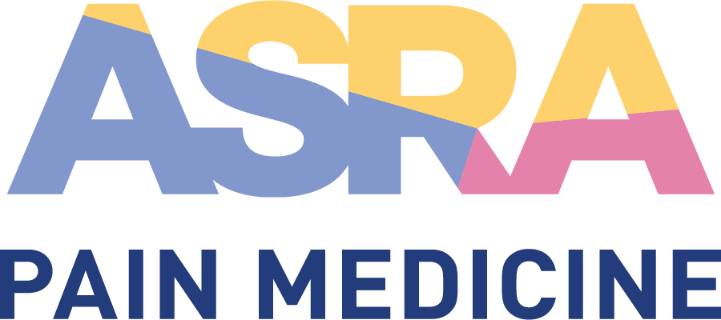
CME Policy

Separation of Promotional from Educational Activities

Title | Separation of Promotional from Educational Activities
Original Approval | 02/2012
Revisions | 09/2013, 12/2013, 03/2014, 06/2014, 07/2022

Purpose
In compliance with the ACCME Standards for Integrity and Independence in Accredited Continuing Education, arrangements for promotional activities (commercial exhibits, advertising, ineligible company representative attendance, etc.) do not influence CME planning or interfere with the presentation of educational content, nor are they a condition of the provision of commercial support for CME activities (no quid pro quo). Therefore, ASRA Pain Medicine CME enforces the following:
- Exhibit and promotional activity fees separate and distinct from commercial support and not a condition of the provision of commercial support
- Separation of promotional activities from the physical space and place of the educational activity
- Separation of promotional activities from the educational course materials
- Non-CME ancillary events guidelines
- Ineligible company representative session attendance guidelines
- Ineligible companies may not discuss CME planning or presentation with faculty
- Ineligible companies may not be the agent providing access to the CME activity
- Onsite compliance monitoring
- Clearly communicated policy requirements to all ineligible companies providing commercial support and/or exhibiting

Definitions

- Commercial Support
Educational Grant
Educational grants provide financial support with nothing in return and in a ‘hands-off’ manner; typically via the online grant submission process. A signed letter of agreement (LOA) is required for this type of commercial support (see point I below).

In-Kind Support
In-kind support provides material or services (any support other than money). A signed LOA is required for this type of commercial support (see point I below).

- Exhibition and Promotional Support
Exhibition
Exhibition refers to any promotional/marketing space provided by ASRA Pain Medicine in return for a fee.

Promotional Support
Promotional support is any funding provided in return for a promotional/marketing opportunity offered by ASRA Pain Medicine. This includes advertisements, bag inserts, tote bags, lanyards, etc. Non-CME Ancillary Events organized by ineligible companies are also included in this category.

Procedure

- Exhibit and Promotional Activity Fees Shall be Separate and Distinct From Commercial Support
- Complimentary exhibit and/or promotional activities will not be provided to those ineligible companies providing commercial support (educational grants or in-kind support).
- A separate and distinct fee must be paid for exhibit space or other promotional activities during the activity for which support was provided.

- Separation of Promotional Activities from the Physical Space and Place of the Educational Activity
- Absolutely no promotional activities will be permitted in the same room immediately prior to, during, or after a CME activity.
- Exhibit materials must be in a room or area separate from the education, and the exhibits must not interfere or in any way compete with the learning experience.
- All promotional activities including interviews, demonstrations, and the distribution of literature or samples must be made within the exhibitor’s space only; canvassing or distributing promotional materials outside the exhibitor’s rented exhibit space is not permitted.
- Specific times are established for exhibit viewing and/or other promotional activities (including industry-organized non-CME ancillary events).
- Food and beverage may be served by ASRA Pain Medicine in the exhibit hall in order to encourage interactions between attendees and exhibiting companies.

- Separation of Promotional Activities from the Educational Course Materials
- ASRA Pain Medicine does not include any product promotional information in its educational materials that are used to support learning during a CME activity (copies of slides, handouts, abstracts, etc.).
- Exceptions to this include:
  - The required commercial support disclosure (company name only in text format; no logos, trade names, or product group messages).
  - Logistical information such as the time/location of industry-organized non-CME ancillary events, exhibitor listing, etc.
- Promotional information is only allowed in logistical support materials (printed program guide, tote bag, etc.). Promotional materials in the program guide will be grouped in a section in the back of the program. Advertisements will be allowed on the back cover. All such materials must be distributed outside the educational meeting room.

- Non-CME Ancillary Event Guidelines
- Any educational session directly influenced, organized, or financed by an ineligible company will be considered an industry-organized Non-CME Ancillary Event.
- Separate times for ancillary events (not competing with educational sessions) will be made available.
- These promotional activities will not offer CME credit by ASRA Pain Medicine or another provider.
- The content outline and speaker selection must be submitted to ASRA Pain Medicine for approval by the Scientific/Education Planning Committee two months prior to the activity.
- Industry supported promotional sessions will be clearly indicated in the meeting timetable/program as: “Non-CME ancillary event organized by…” (the term “sponsored” is not to be used).
- Promotional/marketing materials created by the company must include:
  - “Non-CME Ancillary Event organized by: Company ABC”
  - “The American Society of Regional Anesthesia and Pain Medicine (ASRA Pain Medicine) has provided space for this non-CME ancillary event. The program was independently produced, not subject to review by ASRA Pain Medicine, and is not part of the scientific/educational program offered by ASRA Pain Medicine.”

- Company Representative Participation Guidelines
- Commercial Support (grants and/or in-kind):
  - Complimentary registrations will not be provided to those ineligible companies providing commercial support; a separate and distinct fee must be paid for attendance during the activity for which commercial support was provided.
- Exhibition and Promotional Support:
  - Companies paying the exhibit fee will receive a pre-determined number of exhibitor badges, depending on the size of booth space purchased.
  - Exhibitors are allowed to attend the main meeting sessions at no charge (priority seating to paid participants); standard registration fees must be paid for participation in PBLDs, workshops, special events, etc.
  - In order to receive CME credit, the ineligible company representative must register as a learner and pay the appropriate fees.
  - Absolutely no promotional activities or conversations will be permitted in the educational rooms immediately prior to, during, or after a CME session.
- In-Kind Technical Support:
  - In-kind support is sought from multiple ineligible companies, except when other equal but competing products or services are not available, therefore representatives from multiple ineligible companies will participate.
  - A limited number of technical support badges will be provided for those companies providing support in-kind, requiring representatives to demonstrate the operational aspects or ensure proper functioning of a device.
  - Participation is managed in strict compliance with the ACCME’s Accreditation Criteria and Standards for Integrity and Independence.
    - ASRA Pain Medicine is responsible for all decisions regarding the educational elements (planning, content, faculty selection, presentation, evaluation, etc.). Industry representatives in no way influence any portion of the CME activity; including how the in-kind support will be used or allocated to the educational sessions.
    - Industry employees shall be easily identifiable by their company and meeting badges.
    - The industry representative shall only contribute technical information about the use of the equipment.
    - The industry or ineligible company representative shall NOT expand his or her input into areas of clinical medicine such as:
      - Indications for use
      - Comparisons between competing products
      - Comparisons between the device, invasive surgery, and/or medical treatment.
    - ASRA Pain Medicine’s faculty and staff provide strict supervision to ensure proper professional behavior by industry representatives.
    - ASRA Pain Medicine reserves the right to physically limit the technician’s access to the educational setting, requesting the technician’s participation only when questions arise or further assistance is needed.

- Industry May Not Discuss CME Planning or Presentation with Faculty
Industry representatives shall not influence CME content in any way. Companies should never approach planning committee members or faculty to discuss the planning, presentation, or evaluation of the CME content. Faculty have been instructed to refrain from any such discussions.

- Commercial Interest May Not Be the Agent Providing Access to the CME Activity
- ASRA Pain Medicine never uses a commercial interest as the agent providing a CME activity to learners (distribution of self-study CME activities or arranging for electronic access to CME activities).
- ASRA Pain Medicine may provide a commercial interest with a limited number of brochures for audience generation only, but this is never the sole marketing method (others include direct mail, email promotions, etc.).

- Onsite Monitoring
The separation of promotional materials and activities from the educational arena is strictly enforced throughout the activity by ASRA Pain Medicine’s onsite staff.

- Commercial Support Letter of Agreement (LOA)
The commercial interest and ASRA Pain Medicine will agree in writing to abide by all requirements of the ACCME’s Standards for Integrity and Independence, including, but not limited to all terms, conditions, and purposes indicated in the formal ASRA Pain Medicine LOA. A company’s own LOA may replace the ASRA Pain Medicine standard agreement, but must comply with all ACCME accreditation criteria, Standards for Integrity and Independence, and related policies. The LOA will be signed by both parties and dated prior to the activity.

- Communication of Requirements to Exhibiting Companies
These policies and procedures are communicated to companies providing commercial support in the ASRA Pain Medicine Commercial Support Letter of Agreement and to exhibiting companies in the activity’s Exhibitor Prospectus.

