American Society of Regional Anesthesia and Pain Medicine
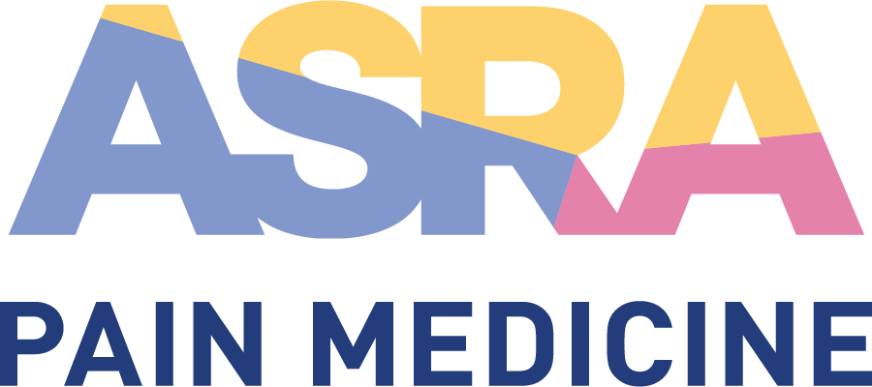

CME Policy

Credit Claiming, Recording, and Reporting

Title | Credit Claiming, Recording, and Reporting
Original Approval | 08/2014
Revisions | 07/09/2022, 02/2018, 08/2017, 04/2016

Purpose
Policy and procedure for verifying and recording physician participation in compliance with the following credit systems:

- AMA PRA Category 1 CreditsTM (as required by the Accreditation Council for Continuing Medical Education related policies).
- American Board of Anesthesiology (ABA)
  - Awarded AMA PRA Category 1 CreditsTM for ABA diplomates.
  - Part II Patient Safety credits ABA-approved for ABA MOCA 2.0™.
  - Part IV High-Fidelity Simulation CME/Improvement in Medical Practice credits ASRA-approved for ABA MOCA 2.0™
- Additional credits, as relevant (American Association of Nurse Practitioners, American Academy of Physicians Assistants, etc.).

Procedure

- AMA PRA Category 1 CreditsTM
In compliance with the ACCME requirements and policies, ASRA Pain Medicine verifies participation and maintains credit records for at least six years from the date of the activity as follows.

Online Credit Claim Process and Certificate Issuance
Attendees are required to claim the number of hours during which they participated in an ASRA Pain Medicine activity. A credit claim form is included in the online course evaluation and credit claim process available directly after the event. Credits per session are included in the daily program and the credit claim form also contains a breakdown per day. Attendees then claim the appropriate number of credits and attest to the extent of their participation with an electronic signature. After approximately three weeks, the online system is closed. The ASRA Pain Medicine office then verifies registration, records the number of credits, and issues the personalized CME certificate based on the attendee’s attestation of participation.

Attendee List with Credits Claimed Spreadsheet
A complete list of participants is compiled to record all relevant registrant information and credits claimed. The spreadsheet includes at least the following:

- First and last name
- Primary degree
- Contact information (email, address, city, state, etc.)
- Attendee category:
- MD/DO/ international equivalencies
- Non-Physician/MD/DO
- Number of AMA PRA Category 1 CreditsTM claimed
- American Board of Anesthesiology (ABA) ID number (if applicable)
- ABA credits claimed (if applicable)
- Other credits claimed (if applicable)

Individual Requests and Manual Credit Claim Process and Certificate Issuance
- After the online evaluation and credit claim system is closed, participants requiring a certificate must submit a completed manual credit claim form. The ASRA Pain Medicine office then confirms registration, records the credits claimed, and issues a certificate

Record Keeping
The attendee list with credits claimed spreadsheet is maintained for at least six years by the ASRA Pain Medicine office.

- Credit Awarded to Faculty Members

  - Credit Earned as Faculty
Per the Accreditation Council for Continuing Medical Education (ACCME) policy, ASRA Pain Medicine does not automatically award credit to faculty for presenting during a CME activity. The basis for this is that teachers and authors provide the link between learner needs and expected results. Faculty are chosen for their ability to facilitate learning in order to achieve the expected result of the activity. Implicit in one’s role as faculty is the expectation that the teacher/author’s expertise and skill is the same as the purpose or objective of the activity. In other words, the teacher’s starting point is the learner’s end point. CME is about learning and change. It is about improvements in competence, or performance, or patient outcomes.

However, the American Medical Association (AMA) does recognize the learning associated with the preparation and teaching of an original presentation. As such, physicians may claim this teaching credit directly from the American Medical Association (AMA) by submitting a Direct Credit Application form (https://edhub.ama-assn.org/DocumentLibrary/edhub/applications/direct-credit-application.pdf) This credit claiming process and related fees are the responsibility of the individual faculty member.

  - Credit Earned as a Learner/Participant
If a faculty member participates in other educational sessions as a learner, faculty may receive credit for those hours spent in the activity. In such cases, faculty must perform the same process as a standard attendee: evaluate the activity, claim CME credit, and receive a CME certificate.

Credit claimed should not include that time the faculty member spent teaching during a session. Therefore, the maximum credit a faculty member may claim as a learner is the full conference credit less the amount of time he/she participated as faculty in a session.

- Credit Reporting to the American Board of Anesthesiology (ABA)
ASRA Pain Medicine is an American Board of Anesthesiology approved provider and as a service to ASRA Pain Medicine members and activity participants, CME credits are reported to the ABA. Participants must include their correctly formatted ABA ID number (34567890) during the online evaluation and credit claim process available directly at the conclusion of the activity. Once the online evaluation and credit claim process is closed, certificates will be issued and credits reported to the ABA. After this time, participants may request their CME certificate by contacting asraassistant@asra.com, but ASRA Pain Medicine will no longer report credits to the ABA, which will then be the individual participant’s responsibility.

For ABA diplomates participating in an ASRA Pain Medicine CME activity, the following credits are reported to the via the ACCME Program and Activity Reporting System (PARS):

- Awarded AMA PRA Category 1 CreditsTM.(total claimed less the Part II Patient Safety credits)
- Part II Patient Safety of the Maintenance of Certification in Anesthesiology Program® (MOCA®), known as MOCA 2.0™ (total claimed deducted from AMA credits)

The following credits are reported directly to the ABA:
- Part IV High-Fidelity Simulation CME / Improvement in Medical Practice of the Maintenance of Certification in Anesthesiology Program® (MOCA®), known as MOCA 2.0™ (reported as is, NOT deducted from the AMA total)

- Additional Credits
ASRA Pain Medicine will obtain additional credits for its CME activities, as necessary to satisfy participants’ continuing education needs.

